DAY-1
1.Find sum of Two Numbers.
#include<stdio.h>
int main()
{
int a=0;
int b=0;
printf("Enter the value of first Number\n");
scanf("%d",&a);
printf("Enter the value of Second Number\n");
scanf("%d",&b);

printf("Addition of a and b is %d\n",a+b);
return 0;
}

OUTPUT:
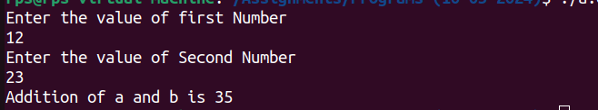

2.Print the String by using scanf by giving user inputs.
Code:
#include<stdio.h>
int main()
{
printf(“Enter the Name::\n”);
char s[20];
scanf("%s",&s);
printf("%s",s);
return 0;
}
Output:
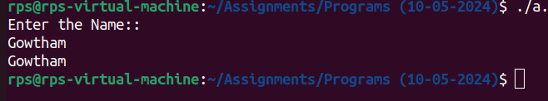
3.Check the Given Number is Even or odd.
Code:
#include<stdio.h>
int main()
{
printf("Enter the Number you want to check\n");
int a;
scanf("%d",&a);
if(a%2==0){
printf("Even Number is %d",a);
}
else
printf("Odd number is %d",a);
return 0;
}
Output:
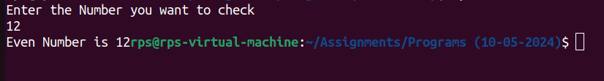
4.Find the ASCII value of an Character.
Code:
#include<stdio.h>
int main()
{
char c;
printf("Enter any Character\n");
scanf("%c",&c);
printf("ASCII value of %c =%d",c,c);
return 0;
}
Output:
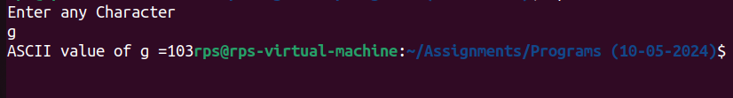
5.Find the Reverse of an Number?
Code:
#include<stdio.h>
int main()
{
int n;
scanf("%d",&n);
int rev=0,t=n;
while(n>0){
int r=n%10;
n=n/10;
rev=rev*10+r;
}
n=t;
printf("Reverse of a Number %d is %d\n",n,rev);
return 0;
}
Output:
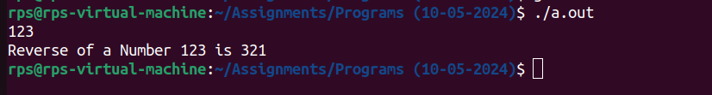
6.Find the time and Date by using time.h header?
Code:
#include<stdio.h>
#include<time.h>
int main()
{
time_t t=time(NULL);
struct tm *ct=localtime(&t);
printf("%s\n",asctime(ct));
return 0;
}
Output:
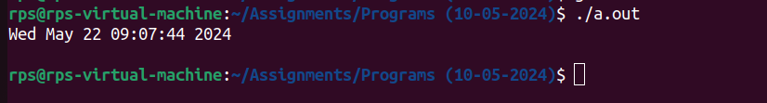
DAY-2
1.Find N Fibnocci Numbers by using for loop.

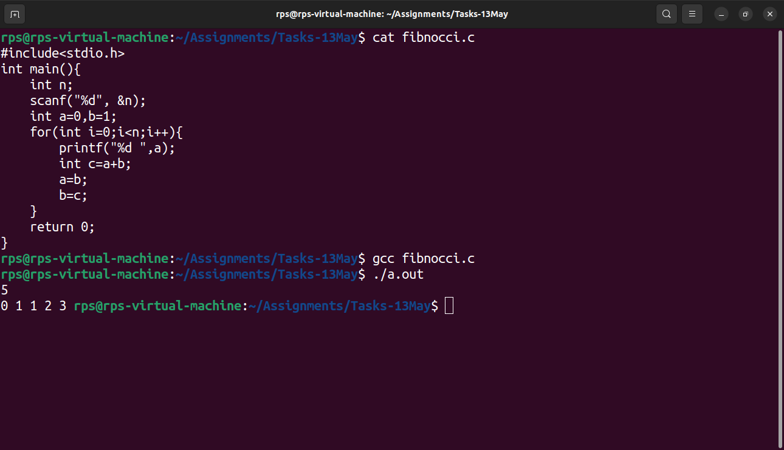
2.Find the Factorial of a Number?
Code:
#include<stdio.h>
int main(){
printf(“Enter the Number \n”);
int a;
scanf("%d",&a);
int fact=1;
for(int i=1;i<=a;i++){
fact=fact*i;
}
printf("Factorial of a Number is %d :%d",a,fact);
return 0;
}

Output:

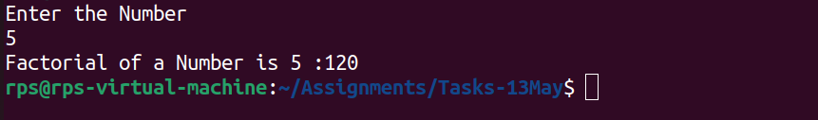

3.Take the inputs from the user and print the matrix.
Code:
#include<stdio.h>
int main(){
int r,c;
printf("Enter the Number of Rows and Columns with space\n");
scanf("%d %d",&r,&c);
printf("Enter the Elements\n");
int a[r][c];
for(int i=0;i<r;i++){
for(int j=0;j<c;j++){
scanf("%d",&a[i][j]);
}
}

printf("Printing the Matrix...");
for(int i=0;i<r;i++){
for(int j=0;j<c;j++){
printf("%d ",a[i][j]);
}
printf("\n");
}
}

Output:
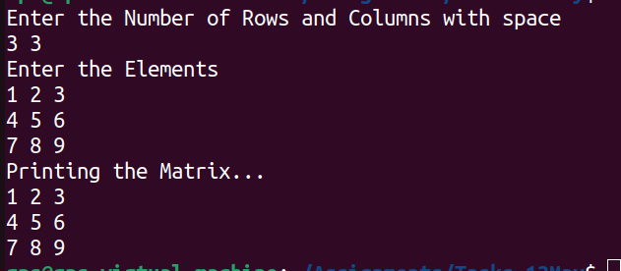
4.Take the inputs from the user and stored into an arrays.
Code:
#include<stdio.h>
int main(){
printf("Task:User want to give inputs from console\n");
int n;
printf("Enter the size of array: ");
scanf("%d", &n);
int a[n];
for(int i=0; i<n; i++){
scanf("%d", &a[i]);
}
}
Output:
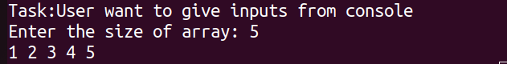
6.Print all the elements in an array with index Numbers?
Code:
#include<stdio.h>
int main(){
printf("Task:Print the Array with index Numbers\n");
int n;
printf("Enter the size of the array: ");
scanf("%d",&n);
int a[n];
printf("Enter the elements of the array: ");
for(int i=0;i<n;i++){
scanf("%d",&a[i]);
}
printf("Resultant Array...!\n");
for(int i=0;i<n;i++){
printf("a[%d] = %d\n",i,a[i]);
}
return 0;
}
Output:

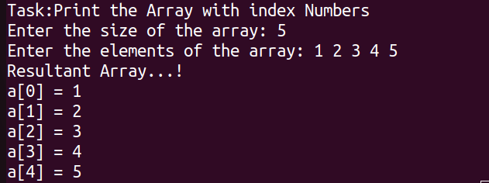
7.Delete a Particular Element in an array.
Code:
#include<stdio.h>
int main(){
printf("Task:Delete a Particular element in an array\n");
int n;
printf("Enter the size of an array\n");
scanf("%d",&n);
int a[n];
printf("Enter the elements of an array\n");
for(int i=0;i<n;i++){
scanf("%d",&a[i]);
}
int k;
printf("Enter the element to be deleted\n");
scanf("%d",&k);
for(int i=0;i<n;i++){
if(a[i]==k){
a[i]=0;
printf(" Deleted Element is %d at index of %d\n",k,i);
printf("Updated value from %d index is %d\n",i,a[i]);
break;
}
else if(i==n-1){
printf("Element not found\n");
}
}
}
Output:
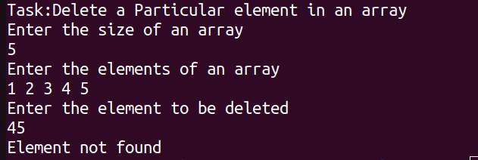
8.Find Duplicate elements in the array?
Code:
#include<stdio.h>
int main(){
// int a[20]={1,2,3,4,5,6,7,8,9,10,2,12,13,14,15,16,18,33,3,1};
printf("Task:Find the duplicate elements in an array\n");
int n;
printf("Enter the size of an array\n");
scanf("%d",&n);
int a[n];
printf("Enter the elements of an array\n");
for(int i=0;i<n;i++){
scanf("%d",&a[i]);
}
int d=0;
for(int i=0;i<n;i++){
int c=0;
for(int j=i;j<n;j++){
if(a[i]==a[j]){
c++;
}
}
if(c>1){
d++;
printf("%d\n",a[i]);
}
}
if(d==0){
printf("No duplicate elements\n");
}
}
Output:
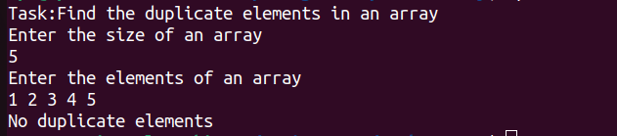

9.Search a Element in an array
code:
#include<stdio.h>
int main(){
printf("Task:Search particular element in an array\n");
int n;
printf("Enter the size of an array\n");
scanf("%d",&n);
int a[n];
printf("Enter the elements of an array\n");
for(int i=0;i<n;i++){
scanf("%d",&a[i]);
}
int k;
printf("Enter the value to be searched\n");
scanf("%d",&k);
int i;
for(i=0;i<n;i++){
if(a[i]==k){
printf("Element found at index %d\n",i);
break;
}
else if(i==n-1){
printf("Element not found\n");
}
}
}
Output:
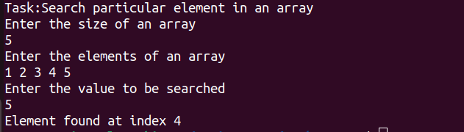
10.Multipilication of Matrix.
Code:
#include<stdio.h>
int main(){
int r,c;
scanf("%d %d",&r,&c);
int a[r][c];
printf("Enter the elements of first matrix:\n");
for(int i=0;i<r;i++){
for(int j=0;j<c;j++){
scanf("%d",&a[i][j]);
}
}
printf("Enter the elements of second matrix:\n");
int b[r][c];
for(int i=0;i<r;i++){
for(int j=0;j<c;j++){
scanf("%d ",&b[i][j]);
}
// printf("\n");
}
int res[r][c];
printf("Multiplication matrix is:\n");
for(int i=0;i<r;i++){
for(int j=0;j<c;j++){
res[i][j]=0;
for(int k=0;k<c;k++){
res[i][j]+=a[i][k]*b[k][j];
}
printf("%d ",res[i][j]);
}

printf("\n");
}
}
Output:
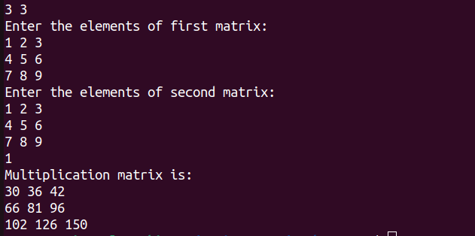
11.Print a Star Program.
Code:
#include<stdio.h>
int main()
{
int n;
scanf("%d",&n);
for(int i=1;i<=n;i++)
{
for(int j=1;j<=i;j++){
printf("* ");
}
printf("\n");
}
}
Output:
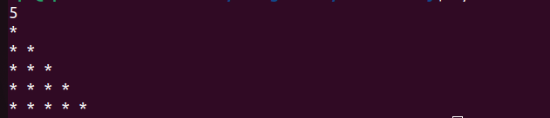
12.Enter the username and domain in While loop the code Behaviour depends on the user interactions.
Code:
#include<stdio.h>
#include<stdbool.h>
int main(){
while(true)
{
start:
printf("Enter the username\n");
char ch[20];
scanf("%s",ch);
printf("Enter the Domain\n");
char ch1[20];
scanf("%s",ch1);
printf("Do you want to continue\n");
printf("Press 1 for Continue\n");
printf("Press 2 for Exit\n");
int a;
scanf("%d",&a);
if(a==2)
break;
else if(a==1)
goto start;
return 0;
}

}
Output:
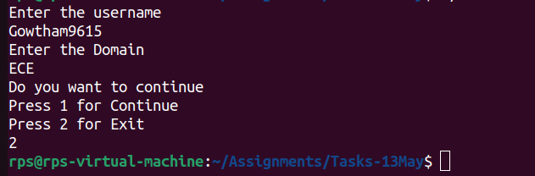
13.Satisfy the do while condition by asking username and domain and exit of the program depends on the user.
Code:
#include<stdio.h>
int main(){
do{
start:
printf("Enter the username\n");
char ch[20];
scanf("%s",ch);
printf("Enter the Domain\n");
char ch1[20];
scanf("%s",ch1);
printf("Do you want to continue\n");
printf("Press 1 for Continue\n");
printf("Press 2 for Exit\n");
int a;
scanf("%d",&a);
if(a==2)
break;
else if(a==1)
goto start;
}
while(1);
}

Output:
